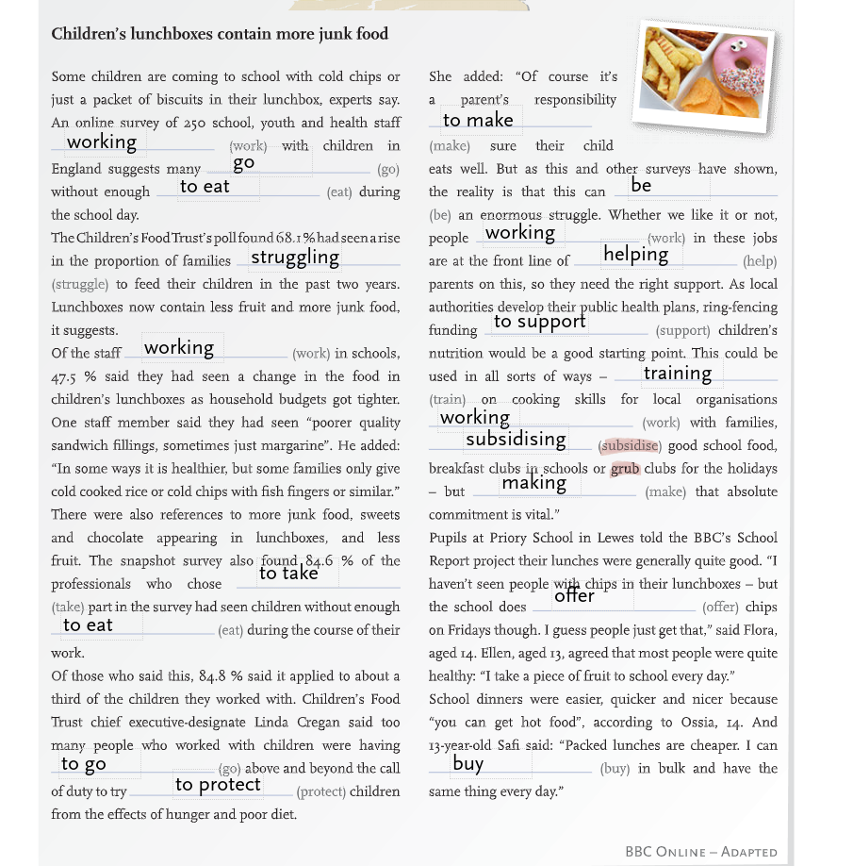

Overtourism in austria:

1: keep people away
2: forced to pay fines
3: life-sized recreation
4: a video of Hallstatt
5: were summer destinations
6: because tourists come all the year
7: get more expensive

